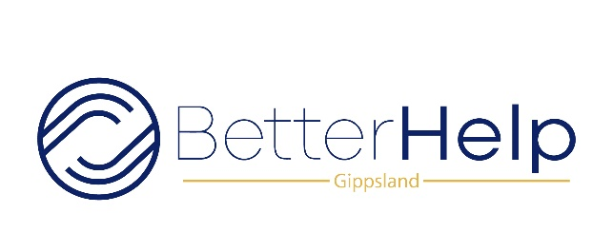
Employee Guidlines

All employees must adhere to the guidelines, policies and
procedures outlined in the onboarding process and Orientation-Induction
program.
Support workers are not permitted to do any of the following, under any circumstances
• Administer medication, including insulin
Rationale: Special NDIS registration and training is required
• Participate in manual handling of any participant
Rationale: Special NDIS registration training is required
• Provide participants of their family/friends with private contact information
Rationale: Participants and care givers must ring the on-call number provided
• Administer any restrictive practices to participants including restraints, locks or other tools provided by caregivers.
Rationale: Special NDIS registration and training is required

Privacy and confidentiality are of the upmost importance. The breaking of
these requirements could result in the termination of your employment with us.

Please sign that you understand the above exclusions as part of your induction and ongoing employment
this document as part of your induction.
Signed : _____________________________________ Date ________________

